Inclusive Schools Week Art Contest
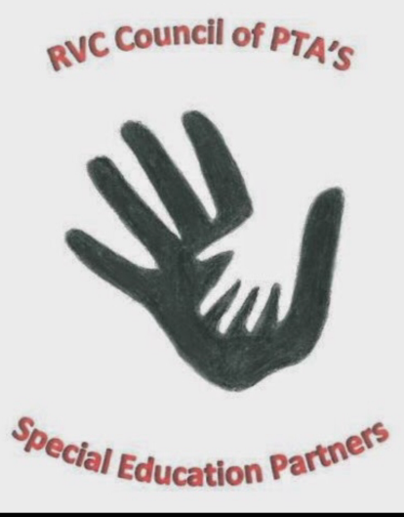

SEP’s theme for Inclusive Schools Week 2019 is “Everyone Counts”

SEP is sponsoring an art contest to see what “Everyone Counts” looks like to you

All entries will be recognized with a certificate of appreciation and winning entries will be displayed in their home buildings and throughout the district

Please consider submitting a design

Rules:
- Artwork must be student’s original design
- Entry must be related to the theme “Everyone Counts”
based on the book “One” by Kathryn Otoshi
- Artwork can be submitted in any format but no larger
than 24 x 36 inches, accompanied by the student’s name, grade and school
- All entries must be submitted to your school’s main office
by Friday December 13, 2019

